
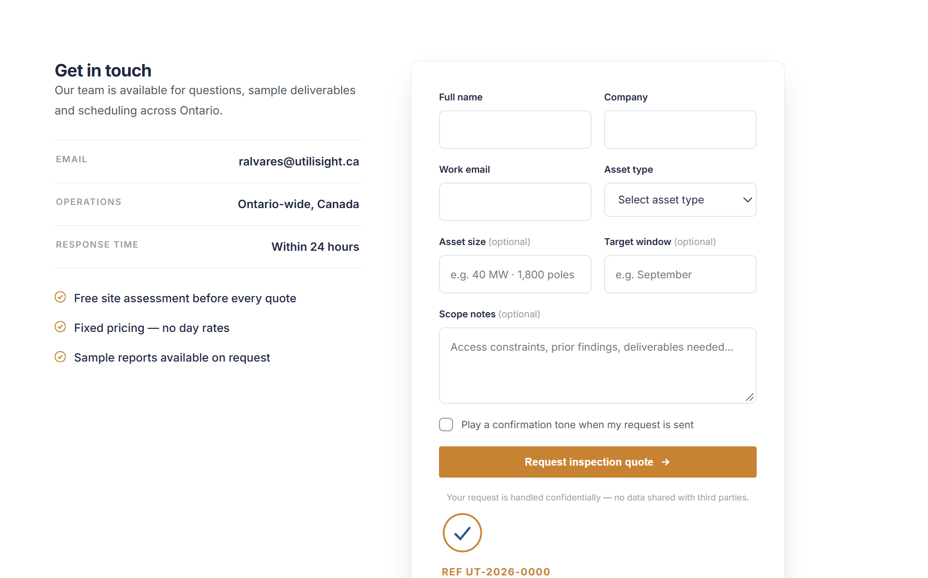
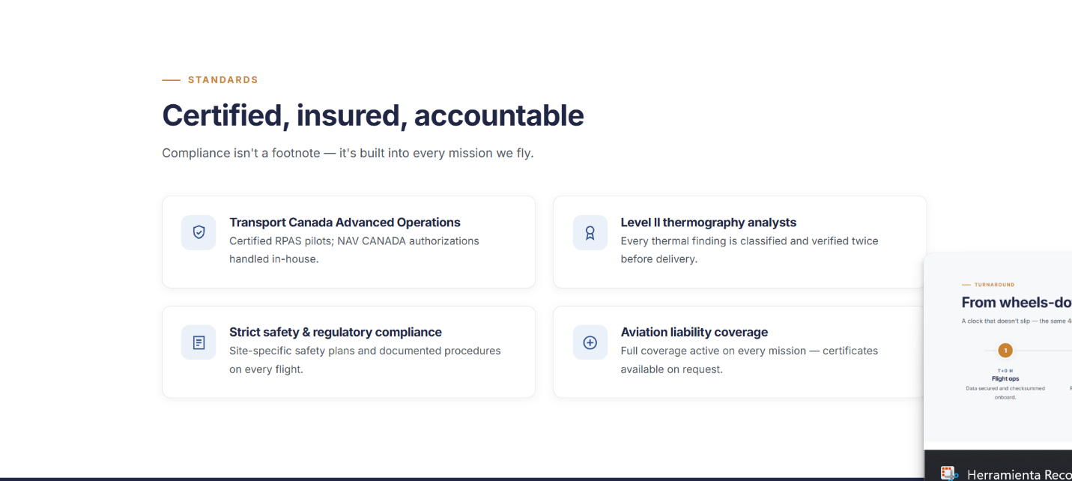
Website Corrections

Color amarillo: #E27D1D
3
2
1

- Logo: Utilizar letras del logo original.
- Certified pilots by transport Canada - Certified thermographer
- Remplazar
80% faster than manual crews - Aerial Asset Inspections
98.6% defect detection accuracy - High-Resolution Visual Data
48–72h report turnaround - Structured Inspection Reports
100% energy-sector focused - Utility & Solar Specialization

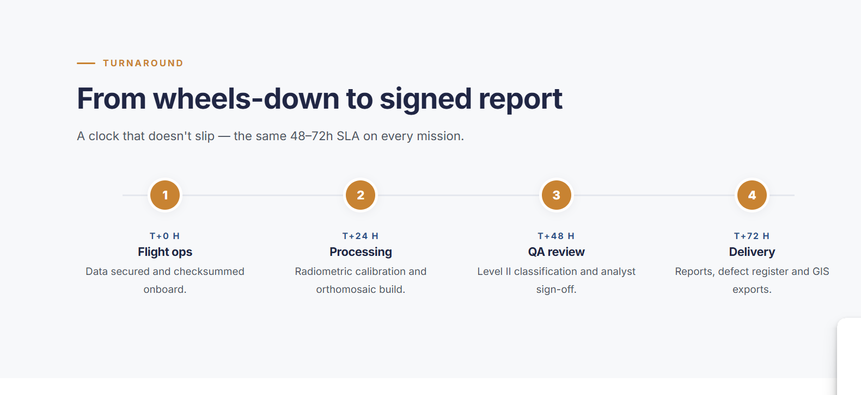
Flight planning
Define inspection objectives, site conditions, flight requirements, and target assets.
2
Aerial data collection
Capture imagery and relevant visual data for the agreed inspection scope.
3
Image review and assessment
Review collected data and document visible conditions, anomalies, and items requiring further assessment.
4
Reporting and delivery
Deliver an organized report with supporting imagery and asset references, as agreed for the project.

